**CSA1086 - Software Engineering**

GitHub File Pulling

STEP 1: Open git bash in the local folder that is a repository

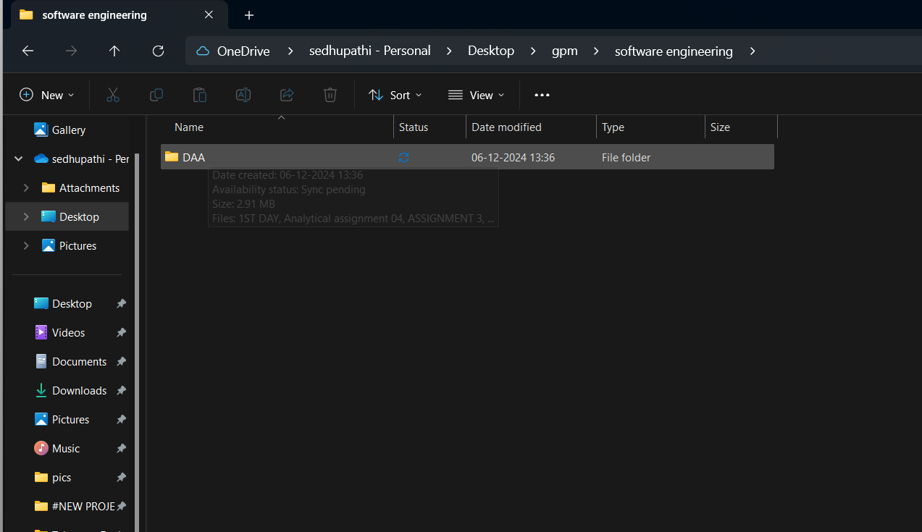

STEP 2: Type git pull

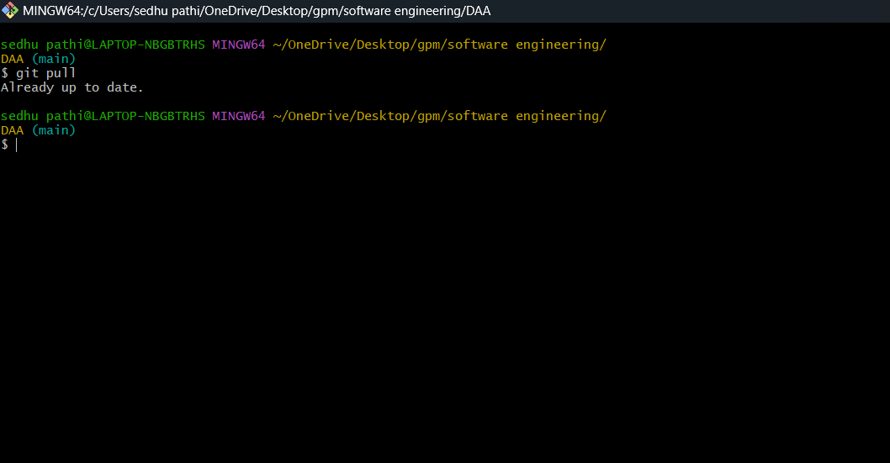

STEP 3: type git pull origin <branch-name> if the data is in different branch

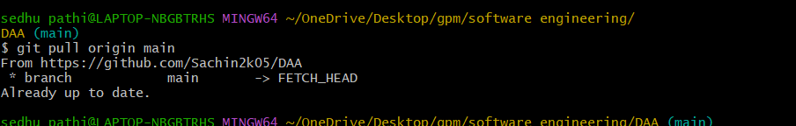

By:

Sachin . E

192324045